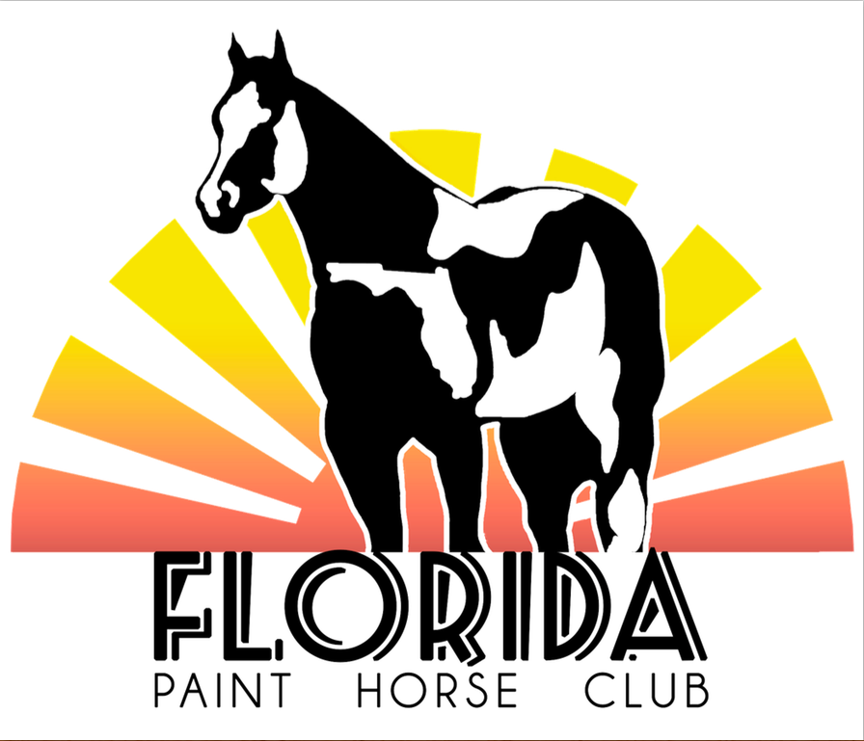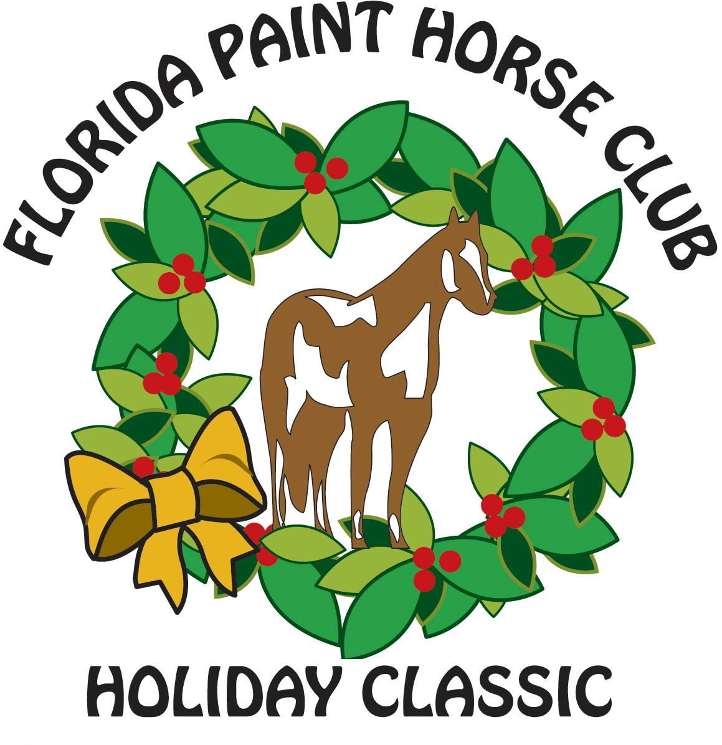
FPHC Sponsorship Opportunities
Exhibitor Events – (All events pending Sponsorship)
___Goodie Box - $350 (Friday)
___Goodie Box - $350 (Saturday)
___Goodie Box - $350 (Sunday)

Class Sponsorships
____ Class_____________________________________ - $50
____ Class_____________________________________ - $50
____ Class_____________________________________ - $50
____ Class_____________________________________ - $50
____ Class_____________________________________ - $50
____ Class_____________________________________ - $50

Show Sponsorships
____High Point Sponsors - $200 – Division_______________
____Reserve Sponsorship - $100 – Division________________
Sponsor Name_____________________________________
Address___________________________________________
City, State, Zip______________________________________
Phone________________ Email_______________________
Please mail this form with Payment to:
Florida Paint Horse Club Florida Paint Horse Club
PO Box 531 or PayPal (Family & Friends)
Floral City, FL 34436 FloridaPHC@gmail.com

